**The 2025 All British Day**

presents

**‘Dressed for Driving’**

**Costume Competition**

The All British Day is proud to announce a costume competition for the 2025 program, a new feature to enhance the level and scale of participation and enjoyment to the days program, for both registered participants and spectators. The theme for the 2025 ABD is 1950, and while special attention will be paid to this date, there are many costume competition categories to ensure as much participation as possible.

Some might be surprised to find that fashion and motoring are inextricably linked. Many who look back through the history of motoring will notice that fashions in clothing have strong associations with their corresponding motoring styles and own fashion trends. Together, especially in the context of historical motoring, they cannot do justice to each other without the accurate pairing of the two. Fashions in clothing have had strong associations with changes in motoring. Only when the two are presented together with articulation and authenticity can the true feel of the era be relived, with a level of nostalgia that we as people often instinctively crave.

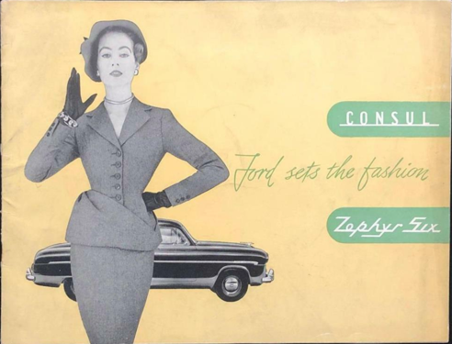 As such the 2025 All British Day also has included with it an invitation for participants in the wearing of historic costume of their choosing. For some, this may simply mean digging out old clothes and wash off the odour of mothballs. For others however, it may be a worthy undertaking of dedication to the cause in of itself. This will give participants the opportunity to showcase a fashion time capsule, that is, fashion paired with the year and style of your vehicle. It might be tempting to brush aside the consideration of participating in the ABD in costume. However, in reality costuming is simply clothing, worn in days past. Days that your vintage or classic car has seen come and go over time.

Costume competitions not only become an activity in of itself, they have the potential to enhance the ABD as a whole. In doing so, we increase the sense of history these beautiful & practical vehicles represent, & offer the public who interact with us, a chance to feel the time and history our cars have lived. For many of the public, the cars will represent a time they were not present for, & this enhances both the enjoyment of the participants and the public alike. So, whether your car is early or late 20th Century there are many easy to wear styles and eras to select from.

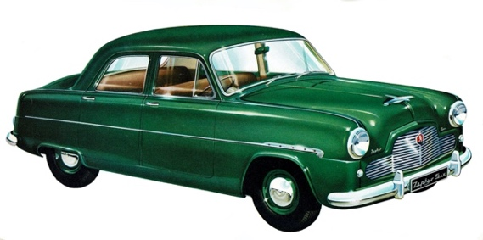As the theme for the day is **1950** there will also be a specific prize category for the best dressed **1950**, both as a single and as a couple.

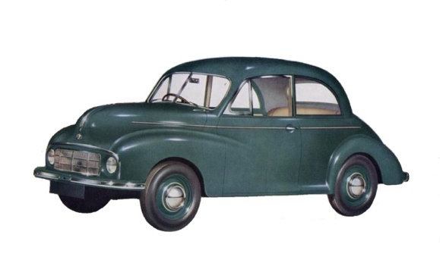

Whether you find original clothing to fit, or make, have made or purchase a commercially made modern vintage inspired item, putting together a costume can be fun for those new to historical dress. Just like vintage cars, some clothing may be found in perfect unaltered condition, fit perfectly & require no improvement. However, like cars, some garments may need a little help to refresh their style, or completely new garments may be constructed & complimented with original accessories.

As original garments and newly made garments cannot be considered totally equal, each type will be judged in their own different categories so that no-one should feel excluded, regardless of opportunity, size, date of fashion and constraints in reproducing historical looks.

**What Will the Judges be Looking For?**

The judges will be looking for historical accuracy, fit and overall presentation, with special attention paid to accessories including footwear, headwear, handbags, gloves, jewellery and hair and makeup. It is important to note that men’s fashions are not as ubiquitous as many would think and their dress features are just as dateable as that of women’s.

Whether entering as an individual, couple or family, fashions should closely match styles worn by drivers of the car in the ***year*** in which the car was manufactured. Stereotyped or generic retro fashions are often not very historically accurate and will be recognised as such, so research is recommended when developing your ensemble. There will be many categories of fashion within the competition including, singles, couples, separate awards for original garments and reproduction (as not everyone has the luxury off finding period clothing that fits), best road side assistance or commercial vehicle, best family and best history bounder.

**About the Judges**

Roxann Legg is a seasoned, award-winning historical costumer with her costumes having won competitions both inside and outside car circles. She specialises in reproducing historical clothing and millinery. Her father was a prolific car restorer and collector both professionally and privately. Growing up she spent many a year in vintage car clubs and runs as far back as the 1970’s, is a current member of the Morris Minor Club of South Australia and curator of the Prospect Hill Museums historical costumes and domestic items.

JoAnne has appeared in many vintage competitions and has been a judge on a number of vintage fashion panels, she has taken her quirky style on a tiny journey while appearing in the ABC series Tiny Oz and has graced the SA history festival poster of ‘transport yourself’. Keep your eye out for her on the streets of Adelaide in her much loved blue 1953 Morris Ute.

Registrations for the costume competition will be taken on the day upon arrival

**Here are a couple of helpful you-tube videos for guidance.**

* **The Glambassador:**  <https://www.youtube.com/watch?v=wqmO4sE75VQ>

This episode ***“What does it mean to look ‘Put Together’”***

* **The Gentleman’s Gazette:** https://www.youtube.com/watch?v=GAerA8gT6h4

This episode ***“What Men REALLY wore in the 1950’s”***